Project Design Phase-II
Technology Stack (Architecture & Stack)
Date | 14 July 2026
Team ID | SWTID-2026-8803
Project Name | Book Doctor Management System
Maximum Marks | 4 Marks

Technical Architecture:
The Book Doctor Management System follows a three-tier MERN architecture: a React.js presentation layer, a Node.js/Express.js application layer implementing MVC with JWT-based authentication, and a MongoDB data layer accessed through Mongoose.

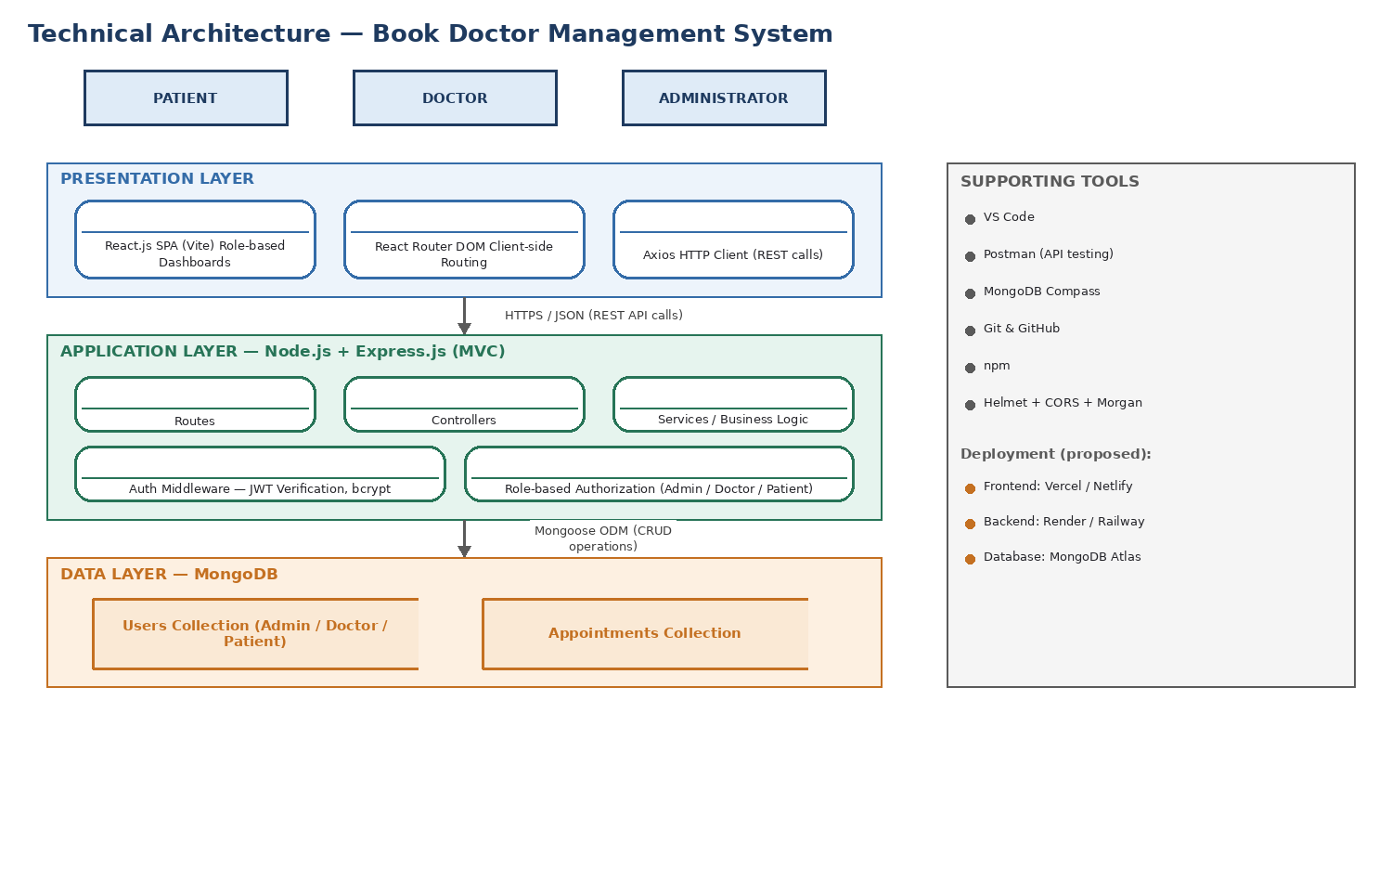
Figure: Technical Architecture — Book Doctor Management System

Table-1 : Components & Technologies:
S.No | Component | Description | Technology
1 | User Interface | Role-based web interface for Patient, Doctor, and Admin dashboards — registration, login, doctor search, booking, and profile screens. | React.js (Vite), React Router DOM, Axios, CSS
2 | Application Logic-1 | User registration, login, and secure session handling. | Node.js, Express.js, JWT, bcrypt
3 | Application Logic-2 | Appointment lifecycle — booking, approval, rejection, rescheduling, and completion. | Express.js Controllers/Services, Mongoose
4 | Application Logic-3 | Admin dashboard analytics — aggregating counts of users, doctors, patients, and appointments in real time. | Express.js Services, Mongoose Aggregation
5 | Database | Stores user accounts and appointment records as JSON-like documents. | MongoDB, Mongoose ODM
6 | Cloud Database | Optional cloud-hosted database for production deployment (local MongoDB used in current build: mongodb://127.0.0.1:27017). | MongoDB Atlas
7 | File Storage | Not required in current scope — no file/image uploads implemented yet. | N/A (planned: local/cloud object storage for reports)
8 | External API-1 | Not integrated in current scope. | Planned: Payment Gateway API (Razorpay/Stripe)
9 | External API-2 | Not integrated in current scope. | Planned: Email/SMS Notification API
10 | Machine Learning Model | Not integrated in current scope. | Planned: AI Healthcare Chatbot (future enhancement)
11 | Infrastructure (Server / Cloud) | Local Server Configuration: Node.js/Express API on http://localhost:5000, React dev server on http://localhost:5173.  Cloud Server Configuration (proposed): Frontend on Vercel/Netlify, Backend on Render/Railway. | Node.js runtime, Vercel, Render

Table-2: Application Characteristics:
S.No | Characteristics | Description | Technology
1 | Open-Source Frameworks | All core frameworks and libraries used in the platform are open-source and MIT-licensed. | React.js, Node.js, Express.js, MongoDB, Mongoose, Axios, React Router DOM
2 | Security Implementations | Password hashing before storage; token-based session authentication; role-based route protection; secure HTTP headers and cross-origin control. | bcrypt, JWT, Auth/Role Middleware, Helmet, CORS
3 | Scalable Architecture | Three-tier architecture (Presentation – React, Application – Express/Node MVC, Data – MongoDB) with stateless JWT authentication, allowing the API layer to scale horizontally behind a load balancer. | MVC Pattern, Stateless REST API
4 | Availability | Stateless REST API design allows multiple backend instances behind a load balancer; MongoDB replica sets can be used in production for database redundancy. | Load Balancer (proposed), MongoDB Replica Set (proposed)
5 | Performance | Indexed MongoDB queries on frequently filtered fields (role, doctor, appointment date); asynchronous non-blocking I/O in Node.js; efficient UI updates via React's Virtual DOM. | MongoDB Indexing, Node.js Event Loop, React Virtual DOM

References:
React.js Documentation — https://react.dev
Node.js Documentation — https://nodejs.org
Express.js Documentation — https://expressjs.com
MongoDB Documentation — https://www.mongodb.com/docs
Mongoose Documentation — https://mongoosejs.com
JWT Documentation — https://jwt.io
GitHub Repository — https://github.com/GOWD-HUB/book-a-doctor

